PREDICTIVE SALES & RESTOCKING DASHBOARD

In Partial Fulfillment of the Requirements for the subject Software Engineering 1

By
Mark Creed P. Angco
Ronan Aleck A. Gatmaitan
Alberto Magno C. Rili
Glenn Jim G. Gamul
BSCS 3A

Submitted to:
Prof: Ryan B. Mateo
2025-2026

ACKNOWLEDGEMENT
The researchers express their foremost gratitude to the Almighty God for providing the wisdom and clarity of thought necessary to bring this project to a successful conclusion. Deep appreciation is also extended to the project professor, Ryan B. Mateo, whose invaluable academic mentorship and unwavering support provided the intellectual framework for this study.
This document represents a significant collaborative effort, and the researchers extend sincere appreciation to all who contributed their expertise. Gratitude is particularly expressed for the steadfast leadership of Mark Creed P. Angco, who steered the team through the process of requirements definition. The study was substantially strengthened by the participation of stakeholders from the Computer Studies Department, especially Ronan Aleck A. Gatmaitan, Alberto Magno C. Rili, and Glenn Jim G. Gamul. Their willingness to share operational knowledge was vital in capturing the business needs.
Furthermore, recognition is given to VAPE CRIB for their crucial analysis and innovative contributions. Finally, the researchers thank all colleagues and support staff who facilitated this process. This document stands as a testament to the collective dedication and collaborative spirit of everyone involved in the Predictive Sales & Restocking Dashboard project.

ABSTRACT
Managing inventory and sales is a significant challenge for businesses where inaccurate forecasting leads to costly stockouts or excess inventory. This document presents the “Predictive Sales & Restocking Dashboard System”, a data-driven solution designed to replace guesswork with actionable insights. The system analyzes historical sales data imported via CSV files to identify trends using established forecasting methods such as moving averages and regression analysis. These insights are delivered through a web-based dashboard featuring clear visual overviews and automatic alerts for low-stock items, enabling more efficient restocking and long-term strategic decision-making. By automating sales predictions, the system seeks to reduce operational costs, improve efficiency, and support sustainable growth. While the system provides robust trend analysis, its accuracy is contingent upon the quality of data provided and remains subject to unexpected market disruptions.

TABLE OF CONTENTS
Section | Page
List of Tables……………………………………………………………………………….. | vi
List of Figures……………………………………………………………………………… | vi
List of Notations…………………………………………………………………………… | vii
List of Abbreviations……………………………………………………………………… | viii
Chapter 1: Introduction………………………….…………………………………………….. | 1
1.1 Project Context…………………………………………………………… | 1
1.2 Purpose and Description…………………………………………………. | 2
1.3 Statement of the Problem………………………………………………... | 3

1.4 Objectives of the Study…………………………………………………... | 3
1.5 Hypotheses of the Study………………………………………………….. | 4
1.6 Scope and Limitations…………………………………………………… | 5
1.7 Definition of Terms………………………………………………………. | 6
Chapter 2: Review of Related Literature……………………………………….. | 7
2.1 Foreign Literature and Studies…………………………………………… | 7
2.2 Local Literature and Studies……………………………………………... | 9
2.3 Synthesis and Research Gap……………………………………………... | 12
Chapter 3: System Design and Methodology……………………………………. | 13

3.1 Research Design………………………………………………………….. | 13
3.2 Research Procedure………………………………………………………. | 19
3.3 Conceptual Design and System Architecture……………………………. | 16
3.4 Data Gathering and Statistical Treatment………………………………... | 28
3.5 Ethical Considerations…………………………………………………… | 28
3.6 Implementation Plan And Result………………………………………… | 30
Chapter 4: Results and Discussion………………………………………………..
4.1 System Development | 31
Chapter 5: Conclusion and Recommendations…………………………………..
References / Bibliography…………………………………………………………
Appendices………………………………………………………………………….

List of Tables
Table 3.1: System Technical Stack Components………………………………….. | 13
Table 3.2: Research Procedure Phases and Activities…………………………….. | 11

List of Figures
Figure 1: Dashboard of the Automated Sales Forecasting and Inventory Control System……………………………………………………………………… | 9
Figure 2: Forecast Report Page……………………………………………………. | 12
Figure 3.1: Entity-Relationship Diagram (ERD)..................................................... | 18
Figure 3.2: Data Flow Diagram (DFD)..................................................................... | 19

List of Notations
Notation | Description
yₜ | The sales value (e.g., quantity) at a given time t.
p | The order of AutoRegression in an ARIMA model.
d | The degree of Integration (differencing) in an ARIMA model.
q | The order of the Moving Average in an ARIMA model.

List of Abbreviations
API | Application Programming Interface
ARIMA | AutoRegressive Integrated Moving Average
CSV | Comma-Separated Values
ERD | Entity-Relationship Diagram
LMS | Learning Management System
ORM | Object-Relational Mapping
POS | Point of Sale
RRL | Review of Related Literature
SME | Small to Medium-sized Enterprise
SQL | Structured Query Language
UI | User Interface
UX | User Experience

CHAPTER 1
INTRODUCTION

1.1 Project Context
The background of this project is rooted in the common yet significant challenges faced by small to medium-sized enterprises (SMEs) in specialized retail. The subject of this case study, VAPE CRIB, is a local business operating in the fast-paced vaping market. This industry is characterized by a high volume of diverse products (e-liquid flavors, device models, accessories) and rapidly changing customer trends.
Currently, VAPE CRIB manages its inventory using a conventional, manual system. That relies heavily on physical stock-takes, basic spreadsheets, and the owner's subjective intuition to make ordering decisions. When shipment arrives, they are manually logged, and re-ordering is handled reactively. This means orders are typically placed only when a staff member notices a product is running low, or when a customer asks for an item that is already out of stock.
This manual and reactive system results in two critical, costly problems: overstocking and understocking. The business frequently orders excessive quantities of slow-moving items, tying up significant capital in “dead stock” that occupies shelf space. Conversely, the store often experiences stockouts of popular, high-demand products, leading to directly lost sales and customer dissatisfaction. This cycle of stock imbalance creates operational inefficiency and financial strain.
To address these issues, this project proposes the development of a "Predictive Sales & Restocking Dashboard”. This web-based decision-support tool moves away from guesswork by using historical sales data to create data-driven forecasts. The system will function by importing past sales history via CSV files and automatically processing that data to identify sales patterns and seasonality. By using predictive models to forecast future demand, the system will display insights on a visual dashboard and proactively generate alerts to notify the owner of low-stock items before they sell out.

1.2 Purpose and Description
The primary purpose of this project is to provide VAPE CRIB with a practical, low-cost tool to optimize inventory management by transitioning from a reactive to a predictive model. The project aims to solve a direct financial problem for a real-world business while demonstrating the utility of data analytics at the small-business level. Specifically, the project consists of a custom-built, web-based software application designed for the owner and management of VAPE CRIB. By implementing this system, the business seeks to reduce costs associated with overstocking, increase revenue by ensuring popular items remain available, and save time by automating complex data analysis.

1.3 Objectives of the Study
General Objective: The general objective of this study is to design, develop, implement, and evaluate a "Predictive Sales & Restocking Dashboard System" to optimize VAPE CRIB's inventory management.

Specific Objectives: To achieve the general objective, this study will:
- To analyze historical sales data from VAPE CRIB to identify and quantify sales patterns and trends.
- To design and develop a forecasting model that can predict future product demand with a reasonable degree of accuracy.
- To create and deploy a functional, web-based dashboard that presents these forecasts and provides actionable low-stock alerts in a clear, visual manner.

1.4 Statement of the Problem
General Problem: VAPE CRIB's current manual and reactive inventory management system is ineffective, leading to a persistent and costly imbalance of stock (overstocking and understocking), which negatively impacts the business's profitability and customer satisfaction.
Specific Problems: This study seeks to investigate the following specific problems:
- How can VAPE CRIB's historical sales data be used to accurately forecast future product demand?
- To what extent does the current manual inventory process result in quantifiable losses from stockouts and overstocking?
- How can a predictive dashboard tool be designed to be user-friendly for a non-technical user, like a small business owner?

1.5 Hypotheses of the Study
This study will test the following hypotheses to determine if the proposed system is a viable solution.
Alternative Hypothesis (H1): The implementation of the "Predictive Sales & Restocking Dashboard System" will lead to a statistically significant improvement in inventory efficiency, defined as a reduction in stockout incidents and a reduction in capital tied to overstocked items.
Null Hypothesis (H0): The implementation of the "Predictive Sales & Restocking Dashboard System" will have no statistically significant effect on inventory efficiency at VAPE CRIB when compared to the existing manual system.

1.6 Scope and Limitations
The scope of this study is focused specifically on the inventory management processes at VAPE CRIB.
The technical development involves a web-based application using a Python (Flask) backend, SQLAlchemy with a PostgreSQL database, and a React frontend. The primary data input consists of historical sales records provided in .csv format. For the predictive component, the system utilizes established forecasting models, specifically ARIMA and Linear Regression, implemented via the statsmodels and scikit-learn libraries. The research follows as a single-case study method with a pre-test/post-test design to measure metrics before and after implementation. It is important to note that the system is a decision-support tool and not a point-of-sale (POS) system; therefore, it will not process live transactions.
This project is subject to several limitations. First, the accuracy of the forecasts is entirely dependent on the quality and consistency of the data provided by the business. Second, the predicted models are based on past patterns and cannot account for external shocks such as new regulations or sudden market competitors. Furthermore, the success of the system depends on user adoption and the staff’s willingness to use the tool. Finally, because this is a single-case study tailored to VAPE CRIB, the findings may not be immediately generalizable to other businesses without modification.

1.7 Definition of Terms
For clarity, the following terms are defined as they are used in this document:.
- Dashboard: A web-based, graphical user interface that provides a visual overview of key information and metrics, such as sales trends and stock levels.
- Forecasting Model: A statistical method (e.g., Moving Average, Exponential Smoothing) that uses historical data to make predictions about future events.
- Inventory Management: The business process of ordering, storing, and using a company's inventory, ensuring the right products are available in the right quantities.
- Overstocking: A situation where a business holds an excess supply of a product relative to its demand, tying up capital and increasing storage costs.
- Predictive Analytics: The use of data, statistical algorithms, and machine learning techniques to identify the likelihood of future outcomes based on historical data.
- SME: Small to Medium-sized Enterprise, referring to businesses falling below certain revenue and employee thresholds.
- Stockout (Understocking): A situation where a business runs out of a specific product, leading to lost sales and potential customer dissatisfaction.

CHAPTER II
REVIEW OF RELATED LITERATURE AND STUDIES

This chapter presents a review of related literature and studies from both foreign and local sources to provide a conceptual and technical foundation for the VAPE CRIB: Predictive Sales & Restocking Dashboard. The following materials discuss the methodologies in time-series forecasting and the development of web-based inventory systems relevant to the current study.

2.1 Foreign Literature and Studies
This section reviews international research, focusing on advanced concepts, system architectures, and the global application of predictive inventory systems.

2.1.1 Real-Time GenAI Dashboards for End-to-End Retail Supply Chain Optimization
The literature consistently highlights the move toward interactive, real-time dashboards for operational excellence. A key study on "Real-Time GenAI Dashboards" emphasizes the transformation of retail supply chains through predictive analytics, showing how a visual interface can rapidly translate complex data into actionable insights to prevent stockouts (Raju, 2025). This directly supports the need for a web-based dashboard at VAPE CRIB.

2.1.2 Validation of ARIMA Models for Product Sales Seasonality and Trends
International research provides robust validation for the models selected for this project. A study on "Predictive Analysis of Retail Sales Forecasting" confirms that machine learning techniques, including regression models, are highly effective for forecasting. The authors note that these models can significantly improve accuracy over simpler methods, which is a core objective of this project (S. et al., 2023). Another study specifically validates the use of ARIMA for time-series forecasting, noting its strength in capturing seasonality and trends in product sales data (Farhan et al., 2024).

2.1.3 Inventory Management and Cost Optimization Strategies
A core goal of this project is cost reduction. Foreign literature on "Inventory Management" stresses that the primary benefit of predictive systems is minimizing the costs associated with holding stock (warehousing, obsolescence) and the opportunity costs of stockouts. The research argues that forecasting is the "cornerstone of effective inventory control" (B. et al., 2024).

2.1.4 Data Science for Inventory Management: Challenges of Data Ingestion and Quality
Research on enterprise resource planning (ERP) adoption in the US and Europe shows that data quality is the biggest challenge. The literature confirms that predictive systems are reliant on clean, well-structured data, and that robust pre-processing (like using Pandas in your tech stack) is necessary to ensure accuracy. A study on "Data Science for Inventory Management" confirms that pre-processing raw sales data is a critical first step before any model (like ARIMA) can be reliably applied (P. & K., 2024).

2.1.5 Development of an Automated Web-Based Sales Forecasting and Inventory Control System
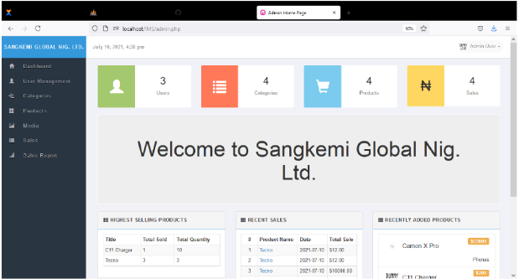
Figure 1: Dashboard of the Automated Sales Forecasting and Inventory Control System
(Source: Al-Salami & Hassan, 2024)
This research presents a functional prototype of a web-based platform designed to bridge the gap between complex forecasting algorithms and daily retail operations. The literature highlights a system architecture where historical sales data is automatically processed to generate inventory replenishment suggestions. A key feature of this work is the user interface, which provides a visual summary of sales trends and stock levels, allowing managers to make data-driven decisions without needing manual calculations. This study serves as a technical benchmark for the "Automated Alert" features of the VAPE CRIB dashboard.

2.2 Local Literature and Studies
This section reviews research from the Philippines, grounding the project in the local context, validating the problem's relevance, and ensuring the solution is technically feasible.

2.2.1 Prediction of Product Sales using Business Analytics
Local academic work has successfully tackled similar problems. The study on "Prediction of Product Sales" developed at the Philippine Women’s University demonstrated the feasibility of creating business analytics applications to forecast sales and evaluate consumer demand using transactional data (Dumlao, 2019). This serves as a strong local precedent for your project's main objective

2.2.2 Web-Based Inventory System with Decision Support for Small Enterprises
A study from the Philippines on "Web-based Inventory System with Decision Support" for a small enterprise highlights the specific need for systems that are not just for logging but also for decision-making (Manlolo et al., 2021). This directly aligns with the "dashboard" and "restocking alert" features of the VAPE CRIB project.

2.2.3 Boosting Sales with Predictive Analysis in the Philippines
Local business publications confirm the value of this project. An article on "Boosting Sales in the Philippines with Predictive Analytics" explicitly states that companies using predictive analytics can "optimize inventory" and "anticipate market demand," which are the exact goals of this case study (RichestPH, 2024).

2.2.4 Inventory Management Systems of Small-Scale Businesses in the Philippines
While the above studies show that sales forecasting is possible, there is still a clear gap. A study on "Inventory Management Systems of Small-Scale Businesses" in the Philippines found that the majority of small businesses still rely on manual methods ("pen and paper") and are hindered by a lack of access to affordable, simple-to-use forecasting tools (Nolasco & Cuaresma, 2024). This study perfectly identifies the gap that the VAPE CRIB system is built to fill.
2.2.5 Data-Driven Point-of-Sale and Inventory System for Pastil Sa Tabi: Integrating Sales Forecasting Algorithms and Predictive Analytics
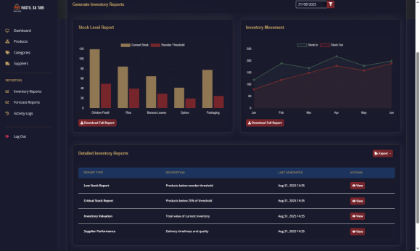
Figure 2: Forecast Report Page
(Source: RSIS International, 2025)
This recent Philippine-based study focuses on the development of a localized Point-of-Sale (POS) and inventory system for a small-scale enterprise. The researchers developed a system that integrates sales forecasting directly into the inventory module to help the business owner anticipate demand for perishable and non-perishable goods. The documentation showcases a prototype with a simplified dashboard designed for local retailers, demonstrating that predictive tools can be made accessible and effective for small businesses in the Philippines. The visual layout of their restocking module provides a direct design precedent for the VAPE CRIB project.

2.3 Synthesis and Research Gap
The reviewed literature and studies provide a comprehensive foundation for the development of the VAPE CRIB: Predictive Sales & Restocking Dashboard. The foreign materials, specifically from Raju (2025) and Al-Salami and Hassan (2024), establish the critical importance of interactive, real-time dashboards that transform raw data into visual, actionable insights. These are supported by the technical validations of S. et al. (2023) and Farhan et al. (2024), which confirm that ARIMA and regression models are highly effective for capturing seasonality and retail trends. Furthermore, B. et al. (2024) and P. & K. (2024) emphasize that the success of such systems depends on robust data pre-processing and a focus on cost optimization to prevent the financial pitfalls of stockouts and overstocking.
On the local front, the works of Dumlao (2019), Manlolo et al. (2021), and the recent RSIS International (2025) study for Pastil sa Tabi demonstrate that web-based inventory systems with predictive modules are not only technically feasible in the Philippines but are also highly effective for small and medium-scale enterprises (SMEs). While RichestPH (2024) highlights the broad business value of these analytics, a significant research gap remains as identified by Nolasco and Cuaresma (2024): the majority of local small-scale businesses still rely on manual, "pen and paper" methods due to a lack of specialized, easy-to-use tools. This project addresses this gap by creating a targeted, data-driven dashboard specifically for the vape retail niche. Unlike general inventory systems, the VAPE CRIB system focuses on the unique challenge of using historical CSV data to generate automated restocking alerts, providing a modern solution for a currently underserved local market.
CHAPTER III
RESEARCH DESIGN AND METHODOLOGY

This chapter presents the systematic approach used in the development of the VAPE CRIB: Predictive Sales & Restocking Dashboard. It outlines the research design, the technical environment including hardware and software specifications, and the data collection procedures required for sales forecasting. Furthermore, this section discusses the development life cycle and the testing methods employed to ensure the accuracy and reliability of the predictive models and restocking alerts.

3.1 Research Design
This study employs a single-case (holistic) instrumental design, which is an in-depth investigation of a single entity.
- Subject of the Study: The subject of this case study is VAPE CRIB, a local small-to-medium-sized enterprise in the vaping retail sector. The study is focused on its inventory management processes and sales data.
- Sampling Technique: A non-probability, purposive sampling technique was used to select the case study. VAPE CRIB was specifically chosen because it perfectly represents the problem under investigation (manual inventory, over/under stocking) and the owner was willing to participate. For the quantitative analysis, the study will not use a "sample" of the data; it will use a census (the entire available dataset) of VAPE CRIB's sales history to ensure the most accurate model.
- Sample Size: The "sample" for the quantitative analysis will be the entire set of historical sales data provided by VAPE CRIB, which is anticipated to be at least 12 months of daily sales transactions.
- Research Method: A mixed-methods approach will be used, combining qualitative data (from interviews) and quantitative data (from sales reports). A pre-test/post-test design will be applied. The "pre-test" phase involves analyzing VAPE CRIB's baseline inventory metrics (e.g., stockout rates, overstock capital) before the system is introduced. The "post-test" phase will measure the exact same metrics after the system has been implemented for a set period, allowing for a direct comparison.

3.2 Research Procedure
The research will be conducted in the following four phases, which integrate the case study procedure with the Prototyping Model of software development.
- Phase 1: Data Gathering and Requirements Analysis
  - Conduct semi-structured interviews with the VAPE CRIB owner to gather qualitative data on existing processes and pain points.
  - Collect the quantitative historical sales data (the "sample") in its raw .csv format.
  - Analyze these requirements to create a formal specification for the software.
- Phase 2: System Design and Prototype Development
  - Design the system architecture, database, and initial UI mockups (wireframes).
  - Develop a "core" functional prototype of the system (e.g., data upload, one forecasting model, one dashboard chart) using the tech stack (Python, Flask, React).
- Phase 3: Prototype Evaluation and Iteration
  - The VAPE CRIB owner ("subject") will test and evaluate the initial prototype.
  - Feedback will be gathered, and the prototype will be refined. This cycle of building, testing, and refining will repeat until the system is complete and meets all user requirements.
- Phase 4: Implementation and Evaluation (Pre-Test/Post-Test)
  - The final, approved system will be implemented for live use at VAPE CRIB.
  - The "post-test" data (new stockout rates, etc.) will be collected over a defined period.
  - This data will be statistically compared to the "pre-test" data to evaluate the system's impact and test the hypotheses.

3.3 Conceptual Design and System Architecture
This section details the technical blueprint of the proposed system, including all diagrams and algorithms.
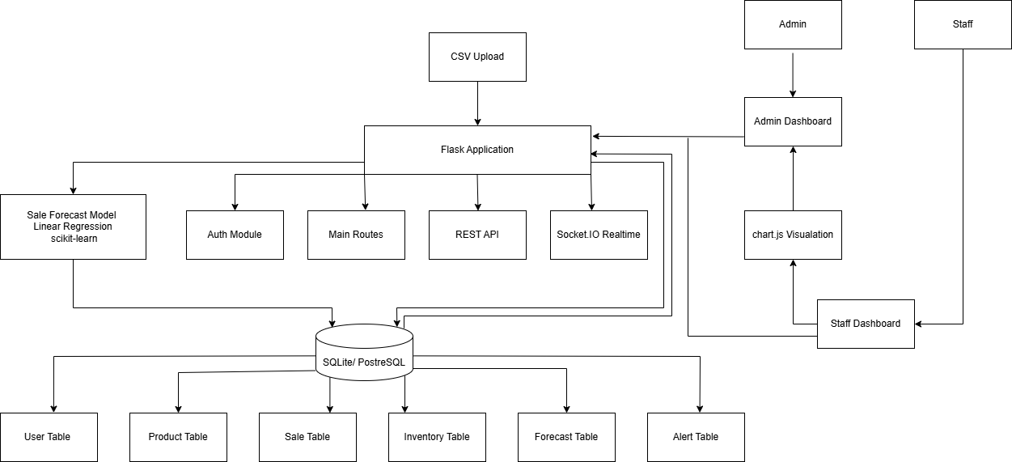
Figure 3.3 System Architecture

- System Architecture (Block Diagram): The system is designed as a modern, three-tier web application:
  - Frontend (Client-Side): The user interface built in React. This is what the user sees and interacts with (charts, alerts).
  - Backend (Server-Side): The "brain" built in Python (Flask). It handles logic, user authentication (Flask-Login), and serves as an API for the frontend.
  - Database (Persistence Layer): The PostgreSQL (or SQLite) database, managed by SQLAlchemy, which stores all data.
  - Forecasting Engine: A Python module within the backend that uses pandas, numpy, and statsmodels to perform calculations.

- Figure 3.1: Entity-Relationship Diagram (ERD)

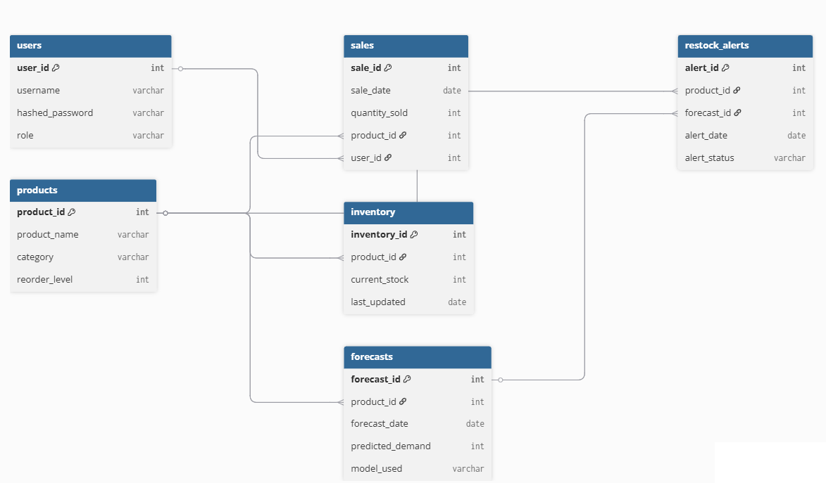
Figure 3.1 Entity Relationship Diagram

This Entity-Relationship Diagram (ERD) illustrates the structure of the VAPE CRIB database, showing the six tables used by the system and how they are connected to each other.
The users table serves as the foundation for system access. It stores the login credentials and role of each person who can use the system, whether they are an Admin or Staff. The user_id is the primary key that uniquely identifies each user, and it is linked to the sales table to track which staff member processed a particular transaction.
The products table acts as the master catalog of all vape items available in the store. Each product has a unique product_id which serves as the primary key, and this is referenced by multiple other tables such as sales, inventory, forecasts, and restock_alerts, making it one of the most connected tables in the entire database.
The sales table records every transaction that takes place in the store. It is connected to both the users table and the products table through foreign keys, meaning each sale entry knows which product was sold and which user processed it. This table feeds data into the inventory and forecasting processes.
The inventory table tracks the current stock level of each product in real time. It is linked to the products table through product_id, so every time a product is sold or restocked, the inventory record for that product can be updated accordingly.
The forecasts table stores the demand predictions generated by the system's forecasting engine. It is connected to the products table so that each forecast is associated with a specific product. The forecast results, in turn, are used by the restock_alerts table to determine when a product needs to be reordered.
Finally, the restock_alerts table ties everything together by flagging products that need restocking. It references both the products table and the forecasts table, meaning each alert is triggered based on a specific product's forecast and its current stock situation. The alert also records the date it was created and whether it has been resolved or is still pending.
Overall, the ERD shows a well-structured relational database where the products table sits at the center, connecting sales, inventory, forecasts, and alerts into one unified system that supports the predictive restocking features of the dashboard.

3.2 Data Dictionary

Table : USER
ID | Column Name | Description | Data Type | Example
PK | user_id | Unique identifier for each user | int | 101
 | username | Login name of the user | varchar | “name”
 | hashed_password | Encrypted password for security | varchar | $2a$10$abc12
 | role | Role of the user (admin/user) | varchar | admin
The User table stores the people who can log into the system. Each user has a username, a secure (hashed) password, and a role (e.g., admin, staff) that controls what they can do.

Table : PRODUCT
ID | Column Name | Description | Data Type | Example
PK | product_id | Unique identifier for each product | int | 501
 | product_name | Name of the product | varchar | "Vape Juice 60ml"
 | category | Product category | varchar | "E-Liquid"
 | reorder_level | Minimum stock before restock alert | int | 10
The Product table is a catalog of all products the business carries. It records each product's name, what category it belongs to, and the minimum stock level (reorder_level) before a restock is needed.

Table : SALES
ID | Column Name | Description | Data Type | Example
PK | sale_id | Unique identifier for each sale | int | 1001
 | sale_date | Date of the sale | date | 1-9-11
 | quantity_sold | Quantity of product sold | int | 5
FK | product_id | ID of the vape product sold | int(FK) | 201
FK | user_id | ID of the customer who purchased the product | int(FK) | 101
The Sales table records every sale transaction. It tracks what was sold (product), how many units, when, and which user processed the sale.

Table : INVENTORY
ID | Column Name | Description | Data Type | Example
PK | inventory_id | Identifier for each inventory record | int | 1000
FK | product_id | ID of the product in inventory(FK) | int(FK) | 102
 | current_stock | Current number of units in stock | varchar | 25
 | last_updated | Last date the inventory record was updated | date | 1-9-11
The Inventory table tracks the current stock level for each product in real time. It shows how many units are on hand right now and when that count was last updated.

Table : FORECASTS

ID | Column Name | Description | Data Type | Example
PK | forecast_id | Identifier for each forecast | int | 600
FK | product_id | ID of the product being forecasted (FK) | int(FK) | 500
 | forecast_date | Date when forecast was created | date | 1-9-11
 | predicted_demand | Predicted number of units needed | int | 40
 | model_used | Forecasting model used to calculate demand | varchar | ARIMA
The Forecast table contains demand predictions for each product. It stores the forecasted date, how many units are expected to be needed, and which forecasting model was used to generate the prediction.

Table : RESTOCK ALERT
ID | Column Name | Description | Data Type | Example
PK | alert_id | Unique identifier for each restock alert | int | 600
FK | product_id | ID of the product being forecasted (FK) | int(FK) | 500
 | forecast_id | ID of the forecast that triggered this alert (FK) | int(FK) | 300
 | alert_date | Date the alert was created | date | 1-9-11
 | alert_status | Status of the alert (pending/resolved) | varchar | pending

The Restock Alert table flags products that need to be restocked. Each alert is tied to a specific product and forecast, has a date it was triggered, and a status (e.g., pending, resolved) to track whether it's been acted on.

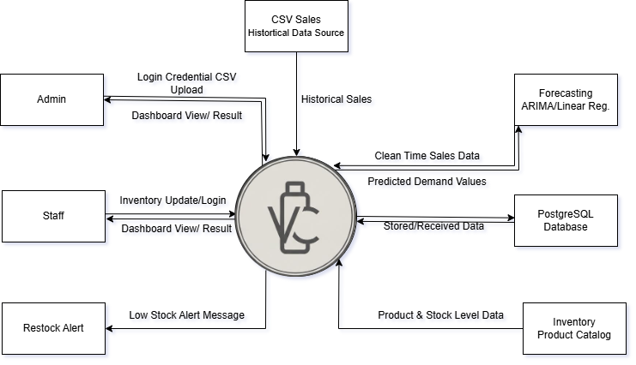
Figure 3.1 Context Diagram
This Context Diagram provides a high-level overview of the VAPE CRIB Predictive Sales & Restocking Dashboard system, showing all the external entities that interact with it and the data that flows in and out of the system. The VAPE CRIB system is represented by the circle at the center, while all the boxes surrounding it represent the external entities that either send data to or receive data from the system.
The CSV Sales Historical Data Source is the starting point of the entire process. It provides the system with historical sales data that will be used as the basis for generating forecasts. This raw sales data flows directly into the system for processing and cleaning.
The Admin interacts with the system in two ways. First, the Admin sends login credentials and uploads CSV files into the system. In return, the system sends back the dashboard view and results, allowing the Admin to see sales forecasts, inventory status, and restock alerts through the dashboard interface.
The Staff also interacts with the system by sending inventory updates and logging in to access the system. Similar to the Admin, the Staff receives the dashboard view and results in return, allowing them to monitor stock levels and view relevant information needed for their daily tasks.
The Restock Alert entity represents the notification output of the system. Whenever the system detects that a product has fallen below its minimum stock level, it automatically sends out a Low Stock Alert Message to notify the concerned users that restocking is needed.
On the right side of the diagram, the Forecasting Engine using ARIMA and Linear Regression receives clean time-series sales data from the system, processes it, and sends back the predicted demand values. These predicted values are then used by the system to generate accurate forecasts and trigger restock alerts when necessary.
The PostgreSQL Database serves as the system's storage engine. It continuously exchanges data with the system by storing and receiving all relevant records, including user information, sales transactions, inventory levels, forecasts, and alert records.
Finally, the Inventory Product Catalog supplies the system with product and stock level data, ensuring that the system always has an up-to-date reference of all available products and their current quantities for accurate inventory analysis and alert generation.

- Figure 3.2: Data Flow Diagram (DFD)
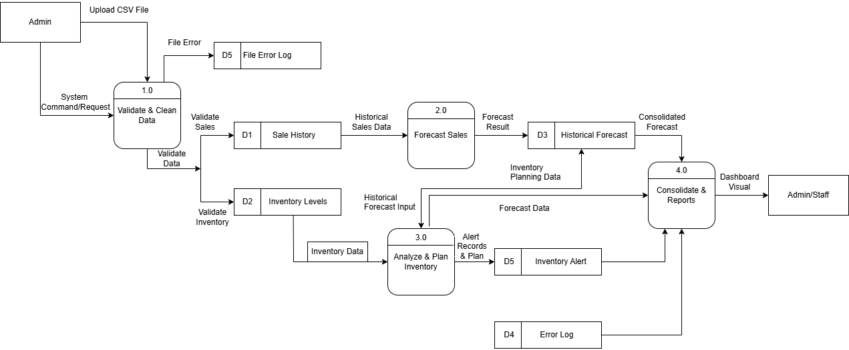
Figure 3.2 Data Flow Diagram (Diagram-1)
This Data Flow Diagram Level 1 (DFD-1) shows the detailed internal processes of the VAPE CRIB Predictive Sales & Restocking Dashboard system, breaking down how data moves through four major processes from the moment the Admin uploads a file all the way to the final dashboard output.
The process begins when the Admin uploads a CSV file into the system and sends a System Command or Request. This triggers the first process, Process 1.0 – Validate & Clean Data, which is responsible for checking the uploaded file for errors and inconsistencies. If the file contains errors, those are immediately recorded into the D5 File Error Log data store so they can be reviewed later. If the data is valid, the process splits into two paths: the validated sales data is stored in the D1 Sale History data store, while the validated inventory data is stored in the D2 Inventory Levels data store.
Once the historical sales data is stored in D1, it flows into Process 2.0 – Forecast Sales, which is the forecasting engine of the system. This process takes the historical sales data and applies forecasting models such as ARIMA or Linear Regression to generate a Forecast Result. The forecast result is then saved into the D3 Historical Forecast data store, which keeps a record of all past forecasts for future reference and comparison.
At the same time, the inventory data from D2 flows into Process 3.0 – Analyze & Plan Inventory, which analyzes current stock levels against the forecast data and inventory planning information coming from D3. This process determines whether any products are running low and need to be restocked. When a low-stock situation is detected, an alert record is created and stored in the D5 Inventory Alert data store. Any errors encountered during this process are logged into the D4 Error Log data store.
All of the results from the previous processes then flow into Process 4.0 – Consolidate & Reports, which gathers the consolidated forecast from D3, the forecast data from Process 3.0, and the inventory alert records from D5. This final process compiles everything into a unified Dashboard Visual output that is then displayed to the Admin and Staff through the system's web-based dashboard.

3.3 Use Case Diagram
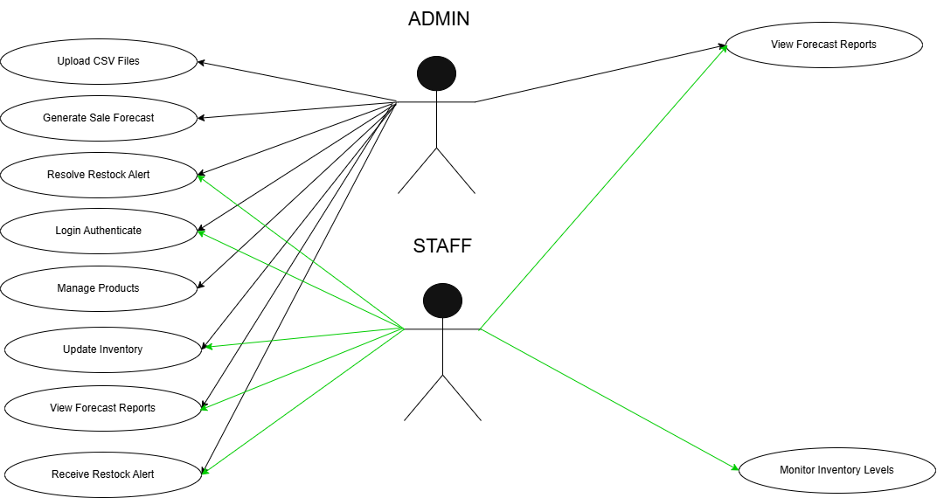
Figure 3.3 Use Case Diagram

This Use Case Diagram illustrates the two types of users in the VAPE CRIB Predictive Sales & Restocking Dashboard system, namely the Admin and the Staff, and the specific actions each user is allowed to perform.
The Admin has full access to the system and can perform all available functions. The Admin can upload CSV files containing historical sales data, generate sale forecasts using the system's forecasting engine, resolve restock alerts once a product has been restocked, and manage products by adding or updating the product catalog. The Admin can also log in to authenticate their identity before accessing the system.
The Staff, on the other hand, has more limited access compared to the Admin. The Staff can log in to the system, update inventory counts when new stocks arrive, and monitor inventory levels to keep track of available products.
Both the Admin and Staff share several common functions. Both users can view forecast reports on the dashboard, receive restock alert notifications when a product falls below its minimum stock level, and update inventory records.
Regarding the colors used in the diagram, the black arrows represent actions that are exclusively performed by the Admin, while the green arrows represent actions that are shared between both the Admin and the Staff, meaning either user can perform those functions.

3.4 Data Gathering and Statistical Treatment
- Data Gathering: The primary data gathering instrument will be the system itself. An upload feature will be built to allow the owner to submit their .csv sales reports. Qualitative data (feedback) will be gathered through semi-structured interviews during the prototyping phase.
- Statistical Treatment: To test the hypotheses and forecast demand, two statistical models will be implemented. This "treatment" will be applied to the cleaned time-series data:
  - Linear Regression (Baseline Model): This model will be used to find a simple, long-term trend. Using scikit-learn, it will answer the question, "Are sales for this product generally increasing or decreasing?"
  - ARIMA (Advanced Model): This is the primary forecasting model. Using the statsmodels library, this model will be trained on each product's sales history to find the optimal parameters (p, d, q) and account for Seasonality, Trends, and Autocorrelation. The output of this model will be the primary forecast shown on the dashboard.

3.5 Ethical Considerations
To protect the subject of the study (VAPE CRIB), the following ethical measures will be strictly enforced:
- Data Anonymization: All business and sales data will be treated as strictly confidential and will not be published in its raw form. All results will be presented in aggregate or anonymized form.
- Secure Access: The deployed system will be password-protected via Flask-Login to ensure only authorized staff can access the dashboard.
- Informed Consent: The owner has provided full informed consent to participate in this case study, with the clear understanding that the goal is to improve their business operations.

3.5 Implementation Plan (SE-1)
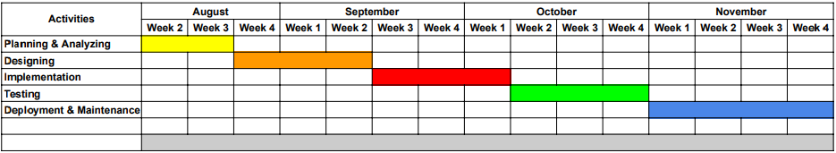
Figure 3.4
Researchers utilize Gantt charts to maintain a structured schedule, ensuring daily tasks are tracked and project milestones are met.

Implementation Result
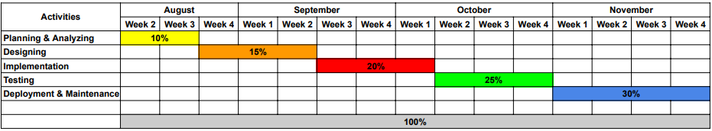
Figure 3.5
The project's progress is tracked via a Gantt chart that distributes the total workload across four months, with each phase assigned a specific percentage of effort. Starting in August, Planning and Analyzing (10%) and Designing (15%) initiate the timeline, followed by Implementation (20%) and Testing (25%) through October. The schedule concludes in November with Deployment and Maintenance, which represents the most significant portion of the work at 30%.

Implementation Plan (SE-2)
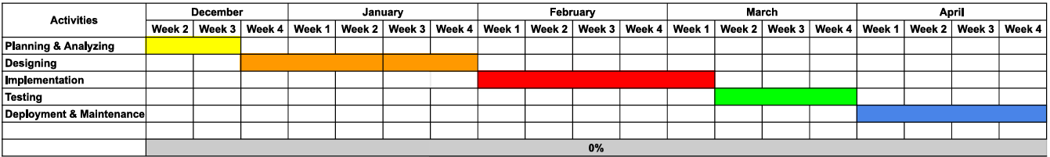
Figure 3.6
For the mobile application, researchers utilize a Gantt chart to manage a structured five-month development cycle beginning in December. The timeline starts with Planning & Analyzing during the second and third weeks of December, immediately transitioning into a lengthy Designing phase that spans from the end of December through the entire month of January. Implementation begins at the start of February and continues for four weeks, leading into the Testing phase, which occupies the first three weeks of March. The schedule concludes with a month-long Deployment & Maintenance phase starting in the final week of March and extending throughout April.

Implementation Result

Figure 3.7
The project's progress is tracked via a Gantt chart that distributes the total workload across four months, starting in the second week of August. The timeline begins with Planning & Analyzing (10%), followed by Designing (15%), which initiates in the final week of August and extends through the first half of September. Implementation (20%) then takes place during the latter half of September, leading into the Testing (25%) phase which spans the entire month of October. The schedule concludes in November with Deployment & Maintenance, representing the most significant portion of the work at 30% of the total effort.
CHAPTER IV
RESULTS AND DISCUSSION
(This chapter presents the actual development of the system, the testing activities conducted, and the results obtained after implementing the system. It discusses how the system was built, tested, and evaluated based on the objectives of the study.)

System Implementation
This section describes how the system was developed and deployed based on the design presented in Chapter III. It includes the programming languages, development tools, frameworks, and hardware or software environments used. This section may also explain how system modules were integrated and how the final system was prepared for use.

Testing Procedures
This section explains the methods used to test the system. It describes the types of testing conducted, such as unit testing, integration testing, system testing, and user acceptance testing. The purpose of this section is to show that the system was tested systematically to ensure correctness and reliability.

Test Cases and Results
This section presents the specific test cases used to verify the functionality of the system. It includes input data, expected results, actual results, and test status (pass or fail). This section demonstrates whether the system functions as intended based on the defined requirements.

Implementation Results
This section discusses the outcomes after the system was fully implemented. It explains whether the system met its objectives, how it performed during actual use, and any issues encountered during implementation. Screenshots or sample outputs may be included to support the discussion.

User Acceptance Testing (UAT)
This section presents the evaluation of the system by actual users. It explains how users tested the system and provided feedback regarding usability, functionality, and performance. The purpose of this section is to determine whether the system is acceptable and useful from the users’ perspective.

Evaluation Summary
This section summarizes the overall results of the system testing and evaluation. It highlights the strengths of the system, identifies any remaining issues, and provides a general assessment of the system’s effectiveness based on testing and user feedback.

CHAPTER V
CONCLUSION AND RECOMMENDATION

Conclusions
- This section presents conclusions based on the objectives of the study. It explains what was achieved and the overall effectiveness of the system.

Recommendations
- This section provides suggestions for system improvement, future enhancements, or further studies related to the project.

Future Enhancements
- This section discusses possible features or improvements that were not implemented due to limitations such as time, resources, or technical constraints. It suggests how the system may be extended or improved in future versions.

REFERENCES
This section lists all books, journals, articles, websites, and other sources cited in the study. All references should follow the APA 7TH EDITION style.

APPENDICES

Relevant Source Code
(Source Code of the System)

User Manual
(Instructions on how to use the System)

